**Faculty of Computers and Information - Cairo University**



**PhD Qualification Exam**

**Program :**PhD

**Course Name:** Algorithms **Date:** 18-10-2018

**Course Code:**   **Duration:** 3 Hours

**Examiner :** DR/ Basheer Youssef **Dr/ ameen Total:**100

**Q1 (5 points)** compute the following recurrence

T(1) =50. T(n) = 4T(n/8) +2n for n = 64.

**Q2 (5 points)** Arrange the following functions in increasing order of growth rate

a)n2log(n) b)2n c)22^n d) nlog(n) e)n2

**Q3 (15 points)** Using master method and substitution method to solve

1. T(n) = 4T(n/2) + n (4 points)
2. T(n) = 4T(n/2) + n2 (4 points)
3. T(n) = 4T(n/2) + n3 (4 points)

**Q4 [20 marks]**

1. Suppose you are choosing between the following three algorithms: **[15 marks]**
2. Algorithm A solves problems by dividing them into five sub problems of half the size, recursively solving each sub problem, and then combining the solutions in linear time.
3. Algorithm B solves problems of size n by recursively solving two sub problems of size

n − 1 and then combining the solutions in constant time.

1. Algorithm C solves problems of size n by dividing them into nine sub problems of size n/3, recursively solving each sub problem, and then combining the solutions in O(n2 ) time.

**What are the running times of each of these algorithms (in big-O notation), and which would you choose?**

1. 3-way-Merge Sort: Suppose that instead of dividing in half at each step of Merge Sort, you divide into thirds, sort each third, and finally combine all of them using a three-way merge subroutine. What is the overall asymptotic running time of this algorithm? (Hint: Note that the merge step can still be implemented in O(n) time.)

**[5 marks]**

**Q5 [15marks] Get MST using prim and Kruskal [7.5 for each one]**

12

8

5

1

2

9

3

1

8

7

5

3

9

10

11

**Q6 [10 marks] Get shortest paths from node S to each node using Dijkstra algorithm**

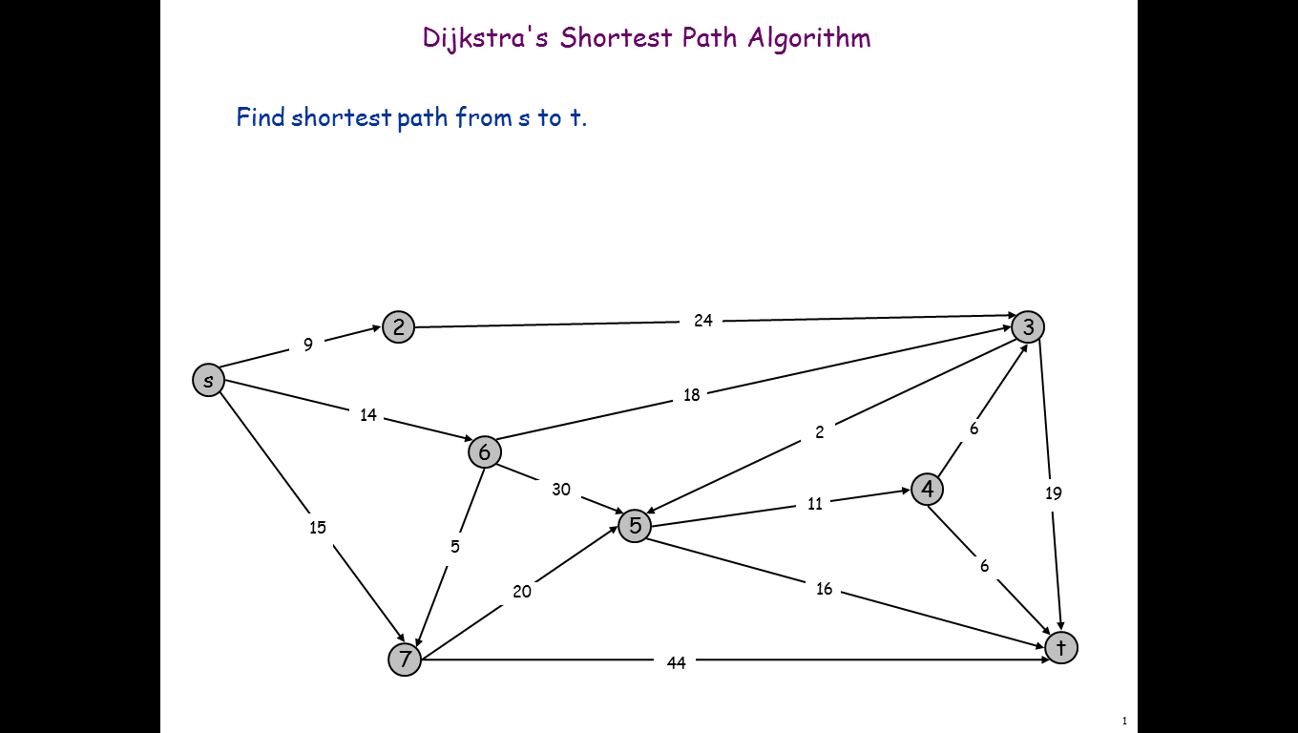

**Q7[10marks]** insert the following numbers in a redblack tree (5,1,4,10,9,20,6,7)

, show each step and show the color of each node and its BH.

**Q8 [10 marks]** Construct variable length code using Huffman for the following characters statistics A = 20 , B =30 , C = 15 , D=5, E=8, and F=22 .

**Q9 [10 marks]** several coins are placed in cells of an n × m board. A robot, located in the upper left cell of the board, needs to collect as many of the coins as possible and bring them to the bottom right cell. On each step, the robot can move either one cell to the right or one cell down from its current location. Design A DP Algorithm to solve this problem, and what is its space and time complexity and use the following counter example to apply your algorithm and what is the maximum number of coins that robot can collect it

Fig 8

***With my best wishes***